**User manual**

**Login screen**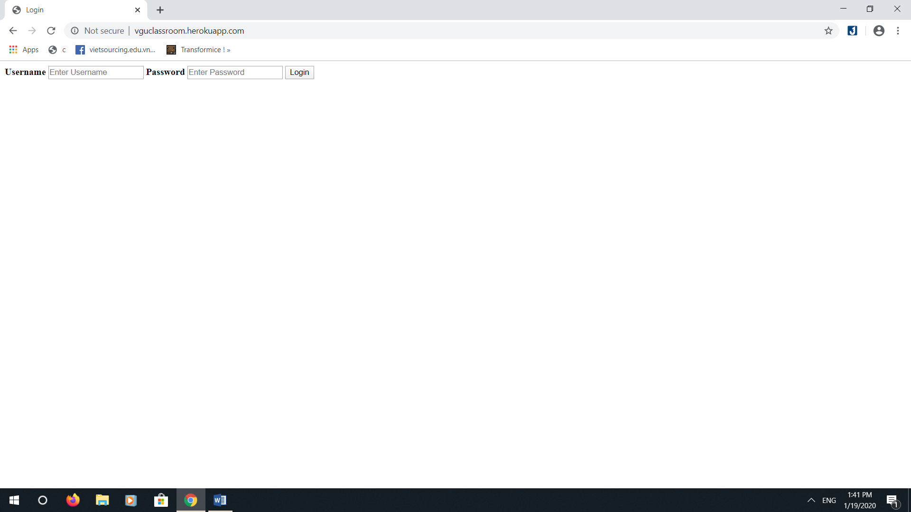

There are just two input fields to input username and password on the login screen. Enter your username and password to log into your accout. After you logged in, the app will appear differently based on your account level. There are 3 levels: Administrator, Lecturer and Student.

**Administrator**

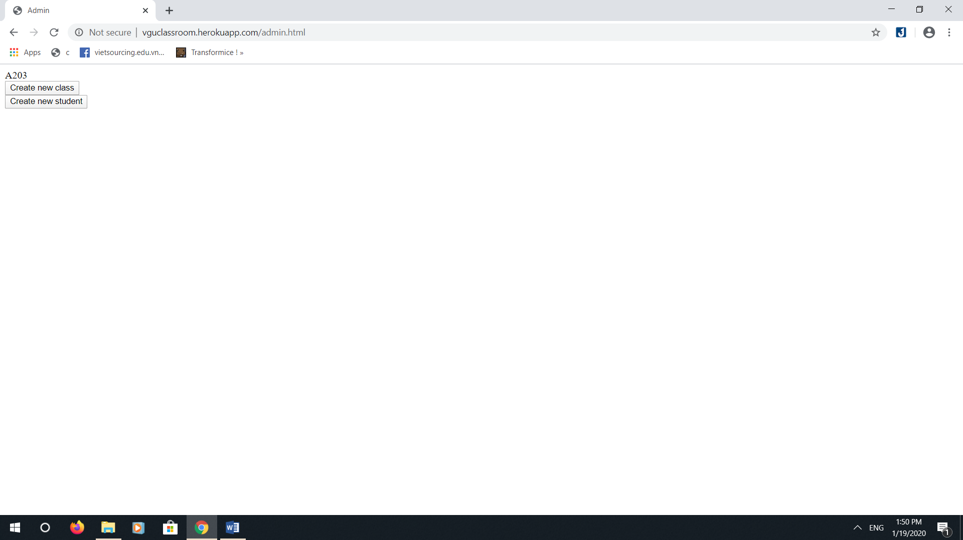

The screen for administrator is simple. The first row states the existing class. There are 2 buttons, one for creating new class and one for creating new student.

**Creating new class**

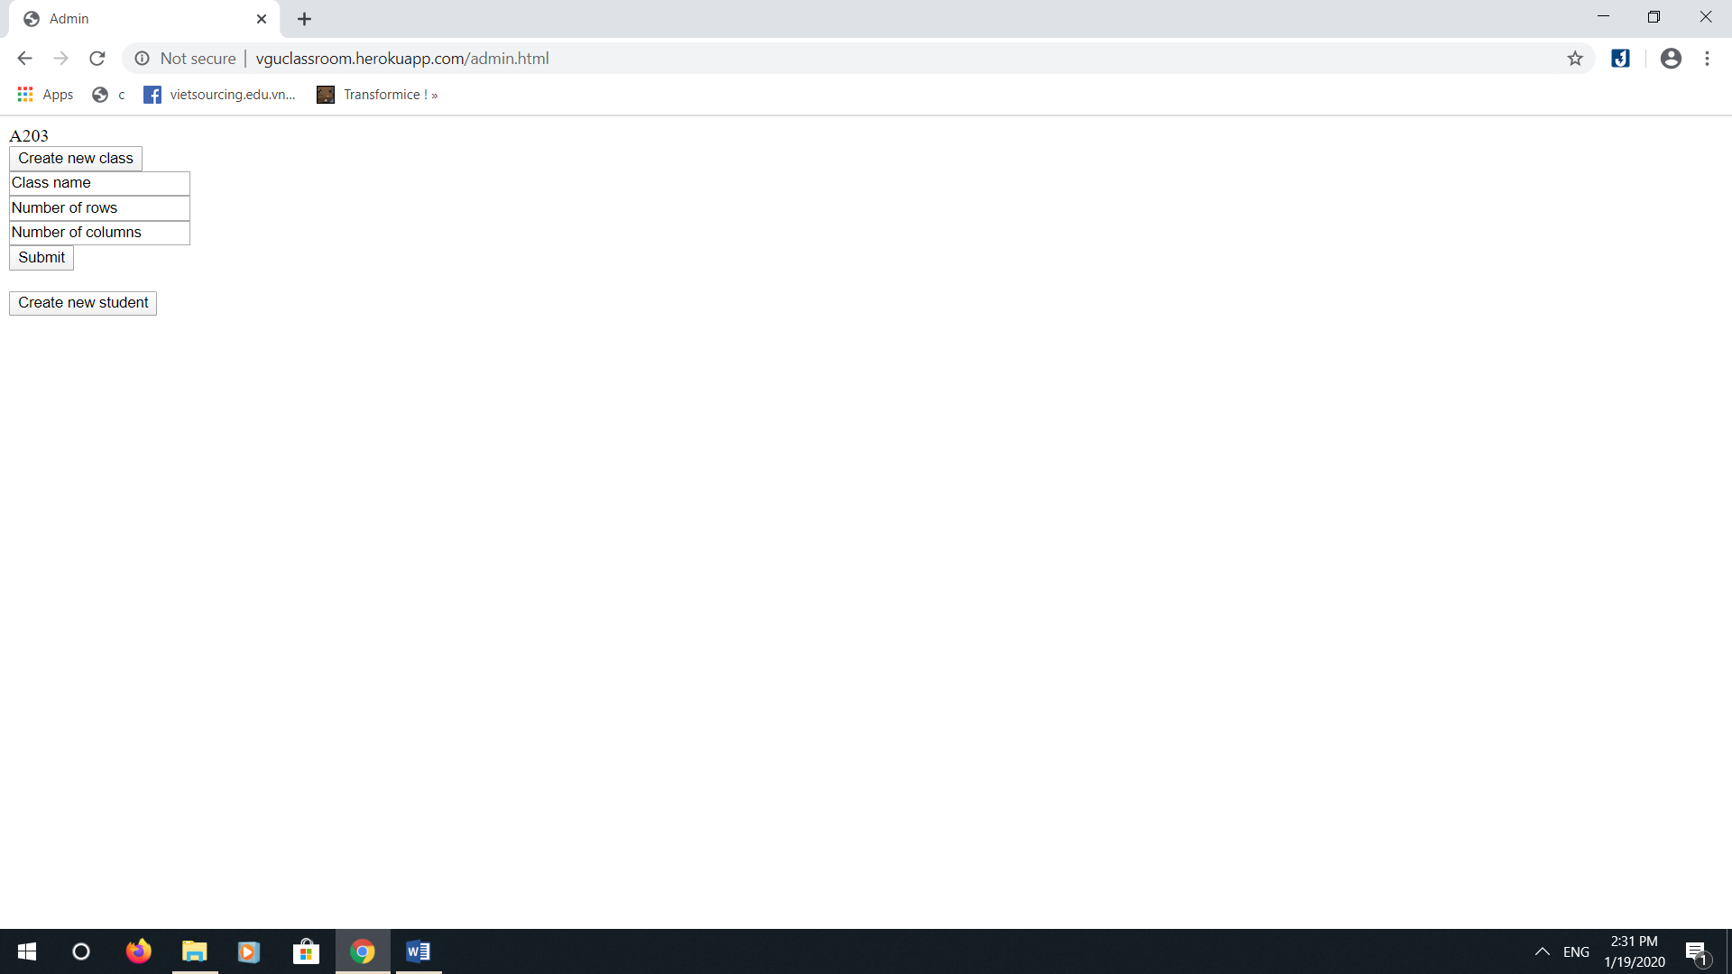

Clicking on the “Create new class” button will show input fields to input the class information. In this application, a seat map of a class is defined as a rectangle. Inputting the right number of rows and columns of seats will help forming the proper “rectangle” of the class map. After inputting all the information needed, click Submit to create a class.

**Creating new student**

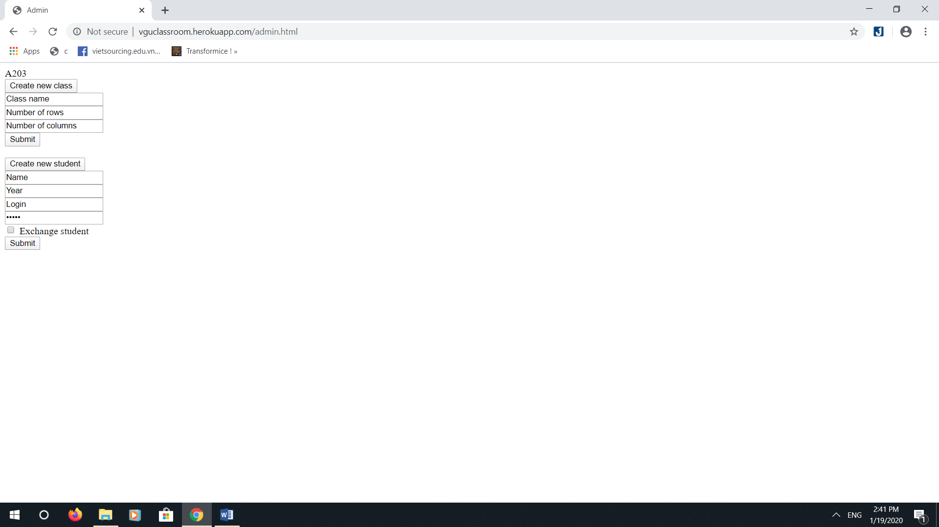

Clicking on the “Create new student” button will show input fields to input the student information. Here, the admin can input the student’s name, intake, username and password for logging into the application, and a checkbox to check if that student is an exchange student. (note: I forgot to add the function to upload the image, I will add it asap). After inputting all the information needed, click Submit to create a student.